Michaela Sullivan

Intro to Bioinformatics

Professor Harbert

11/26/19

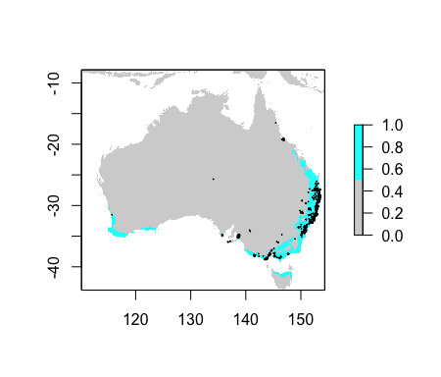

Figure 1: Species Distribution Model of *Phascolarctos cinereus* in Australia

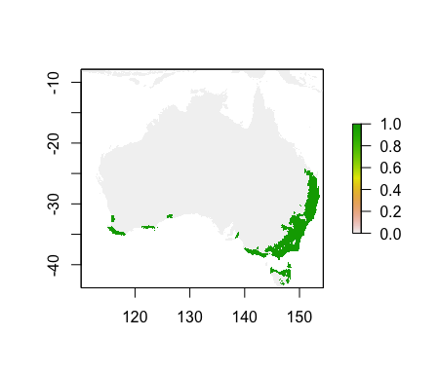

Figure 2: Future Species Distribution Model of *Phascolarctos cinereus* in Australia in 100 years

The Species Distribution Model (SDM) of *Phascolarctos cinereus*, commonly known as the koala, highlights that this species is generally found on the southern coast of Western Australia and on the coasts of Victoria, New South Wales, Queensland and Tasmania (Figure 1). This model is based on the SDM with the lowest Akaike Information Criterion (AIC). One reason why *Phascolarctos cinereus* might live near the coast like this model predicts is because they live in eucalyptus trees and these types of trees might thrive on the soil near the ocean.

The points on this model represent the areas where *Phascolarctos cinereus* have been recorded on Gbif (Figure 1). These sightings generally correlate with the Worldclim data, but not many koalas have been spotted on the south western coast like the model suggests. This lack of correlation could be because people might not visit the south western coast Australia very often, so they might not be able to record the presence of koalas there.

The future SDM of *Phascolarctos cinereus* predicts that that the species distribution will marginally change over 100 years. This model slightly differs from the first model because the area in which *Phascolarctos cinereus* live expanded a little across the coast and inland. This model makes sense because the population of koalas should expand over 100 years, but koalas should generally populate the same area that they have previously populated, since this area appears to be a part of Australia where they seem to thrive. One part of this model that I question is the small mass of koalas in the 125, -38 region. The gap between this population of *Phascolarctos cinereus* and the other population on the coast of Western Australia seems odd because I would have predicted that the koalas would have migrated east together, so that the gap between the two populations would be filled in.